INDEX
S.No. | Title for Practicals | Page No.
1 | Write a program in Python to insert elements in an Array | 2
2 | Write a program in Python to delete Elements in an Array | 4
3 | Write a program in Python to find the product of two matrices | 5
4 | Sum of Diagonal and Non-Diagonal Elements in Matrix | 7
5 | Marks Calculation | 9
6 | Operations of stacks and its Applications | 12
7 | General and Circular Queue Operations | 21
8 | Infix to Postfix Expression | 28
9 | Quick Sort | 31

Q.1. Write a program in Python to Insert an element in the Array.

Arrays are the special Linear Data Structures that we can use to store any amount of homogenous (same set of elements) data elements in a contiguous and sequential order.
If you were to use any old programming language, the array length is usually fixed in size.
Here in Python, the array size can either be fixed or dynamic, as in, the array length is calculated while the user is putting the values when the program is executing.
This dynamic feature takes away that problem of fixed array length and not being able to insert more elements to the Data Structure.
Here is how the insertion in an array looks like:
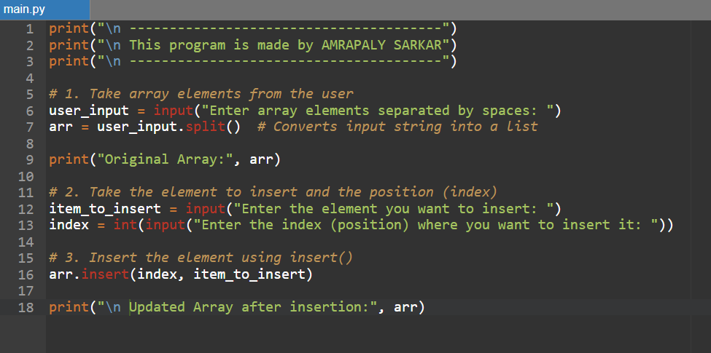
Code for Insertion Array
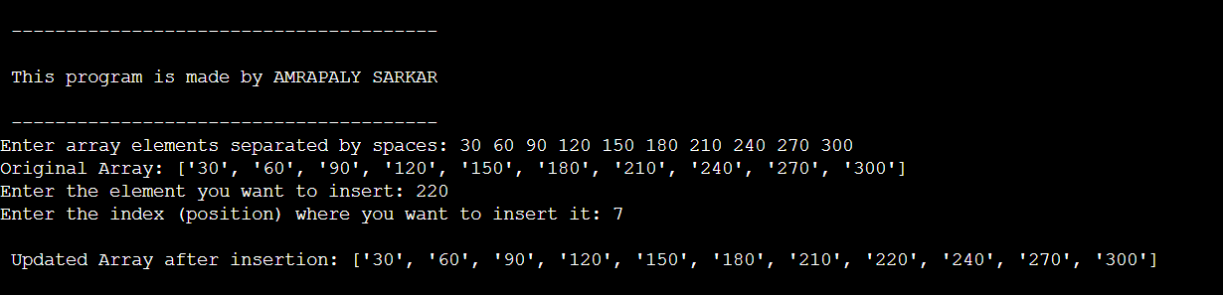
This is how insertion in array works in Python.

Q.2. Write a program in Python to delete an element from array.

Arrays are a Linear Data Structure that stores the data elements in a sequential and contiguous manner.
Now, the program to delete an element from the array:
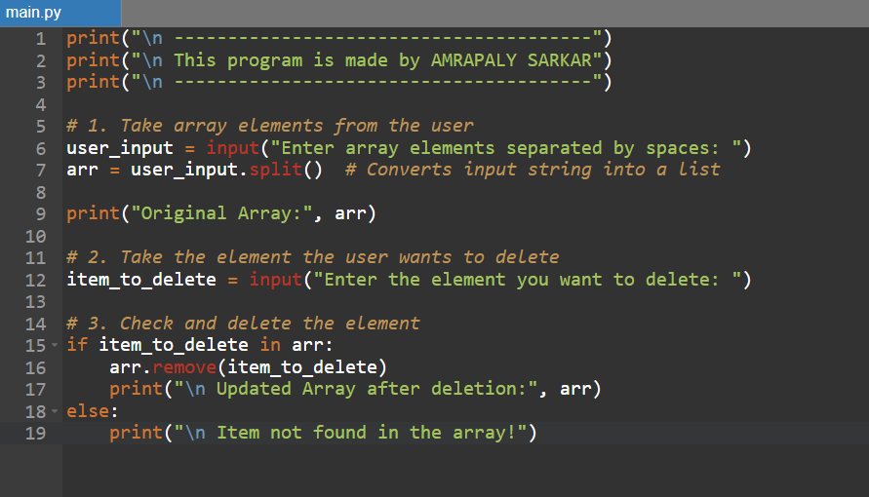
Let’s see how it works: 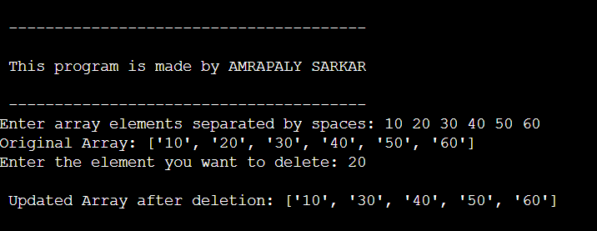
Q.3. Write a program in Python to find the product of two matrices.

This program shows how to get the product of two matrices:
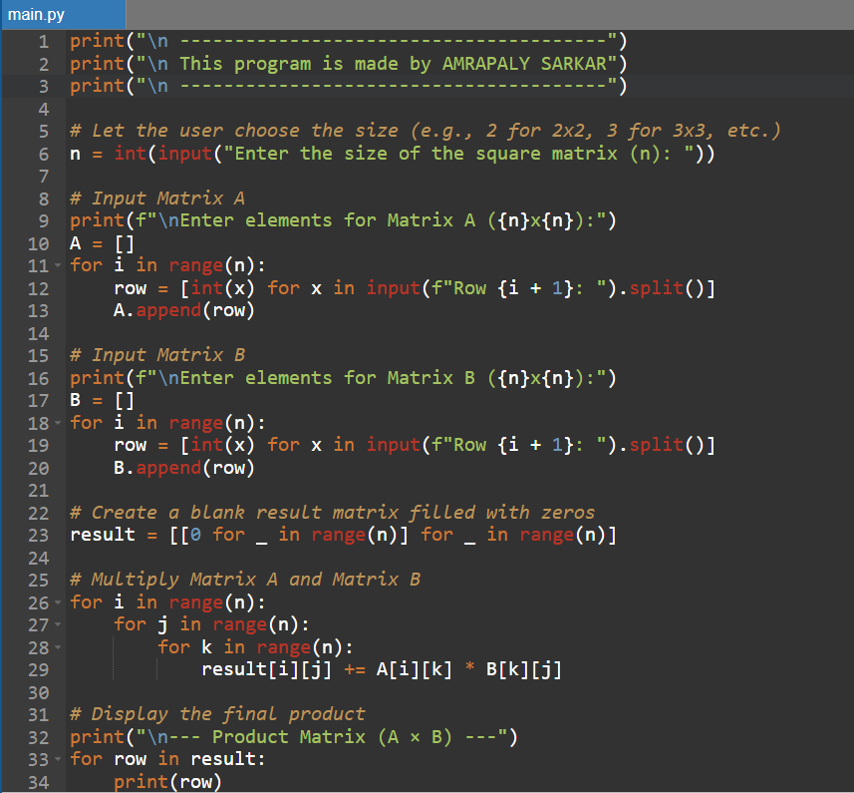
Let us see how the program works.
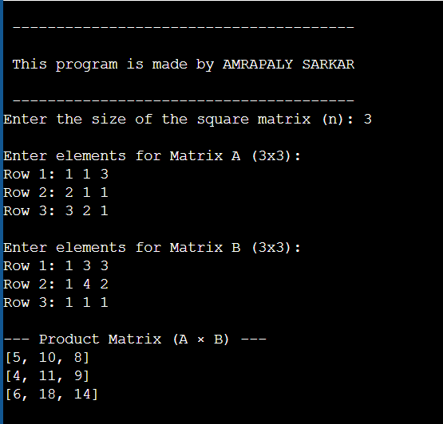

Thus, this is the program to calculate the product of two matrices.

Q.4. Write a program in Python to find the sum of diagonal elements as well as the non-diagonal elements of a matrix.

Here is a program to perform the sum of diagonal elements in a matrix and also calculating the sum of the non-diagonal elements in a matrix.
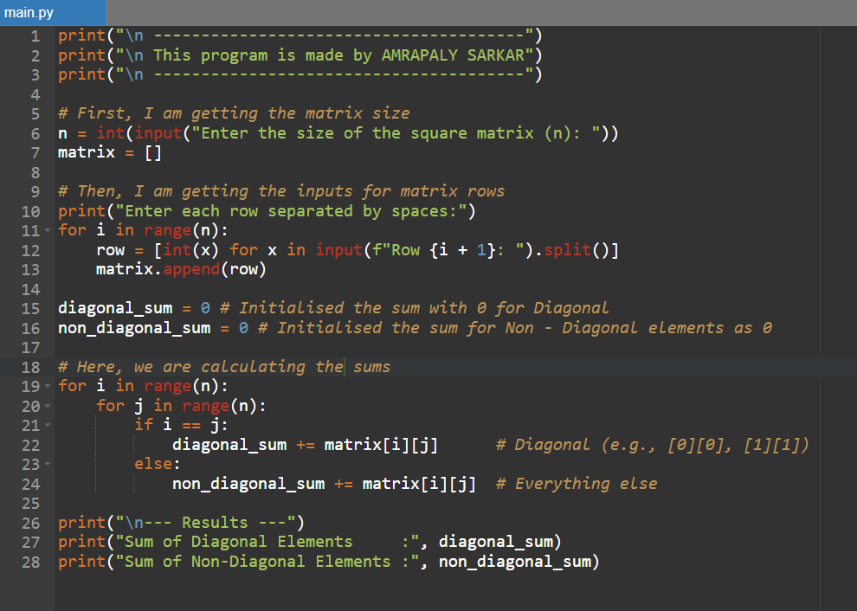
Let us see how this program works.
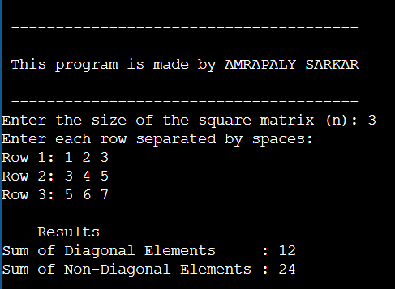

Thus, this is our program for finding the sum of:
- Diagonal
- Non-Diagonal

Q.5. Write a program in Python to enter marks of 5 students for 3 subjects each and find the percentages of students marks.

This program shows the results of 5 students in 3 different subjects each:
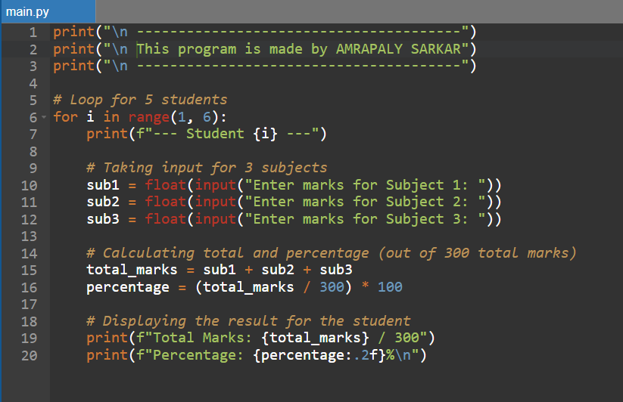
Let us see how this program works.
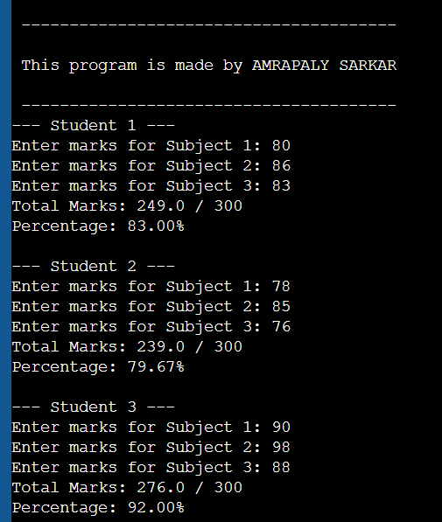
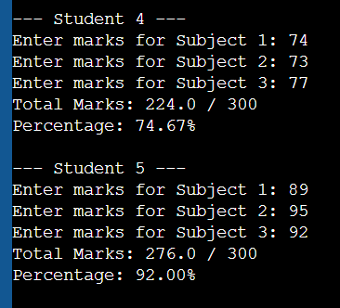

Thus, this is a program for calculating 5 students’ marks in 3 different subjects, with the maximum marks being 100.

Q.6. Write a program in Python to perform the following Stack operations:
- Basic Operations:
- Insertion
- Deletion
- Overflow Condition
- Underflow Condition
- Reverse of a string.
- Parenthesis Matching.

A Stack is a Linear Data Structure, following the principle of LIFO (Last In, First Out), which means, that the element that is inserted into the stack at the very last, will be the first one to ‘pop’ or delete from the stack.
The main focus for the first part of our program is:
- Basic Operations on Stack:
The program (as shown in the screenshots below) compiles all of the basic operations that you can perform in the Stack.
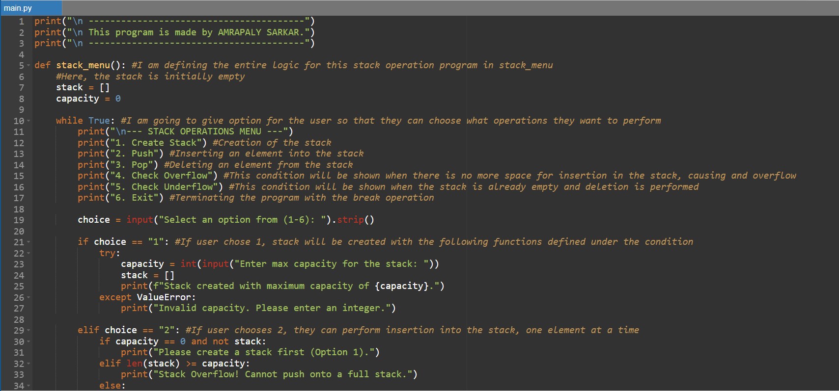
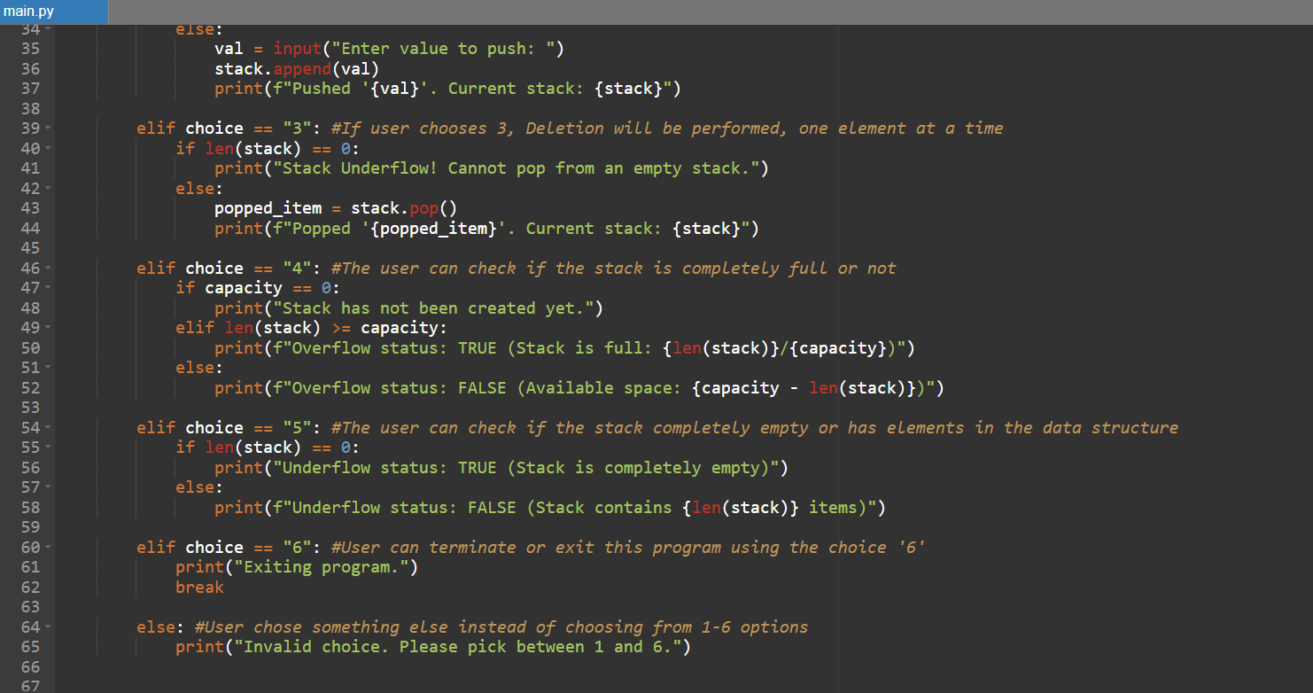
Now, let us create a stack:
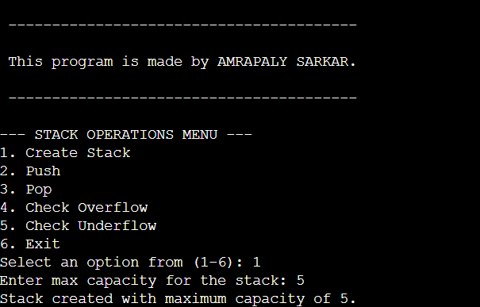
Our stack with the capacity to hold 5 data elements is created!
Let us move on to Insertion:
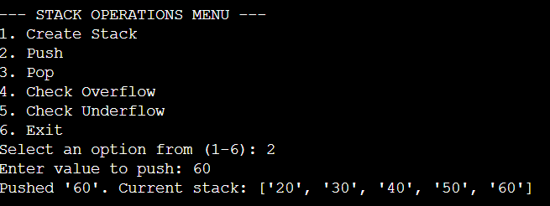
We have inserted 5 elements: [20, 30, 40, 50, 60], into the stack, using the push operation. The stack is full.
Let us check for overflow:
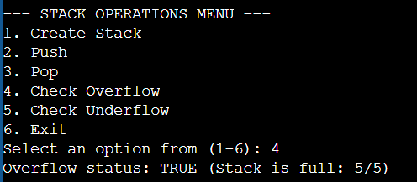
The stack is overflowing, and will not store anymore elements as the maximum capacity for the stack was 5 and we inserted 5 elements in the stack.
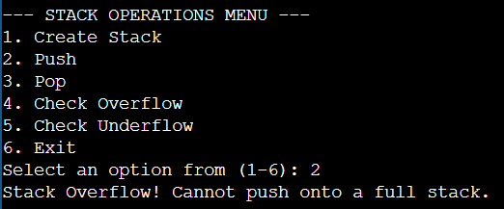
As we can see, when we tried to insert an element, it printed out ‘Stack Overflow!’ Thus, no more elements can be stored in the stack.
Let us delete some elements (Pop Operation):
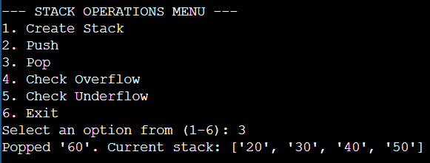
When we performed deletion on the Stack, ‘60’ popped out, following the LIFO principle. ‘60’ was the last element that was pushed into the stack, so, according to LIFO, ‘60’ will also be the first one to be deleted or ‘popped’ out of the stack.
Checking Underflow:
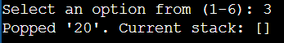
Just like how we popped ‘60’ out of the stack, we popped the other elements in the stack, following that same process. We can see that the stack is now empty. So, if you try to delete again, this message will pop up:
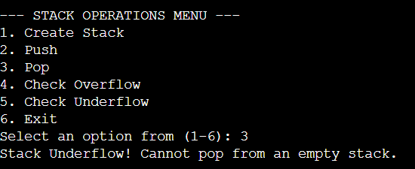
The message ‘Stack Underflow!’ will appear on the screen if you try to delete or perform the ‘pop’ operation.
Thus, these were some of the basic operations in a stack. Now, let us move on to the next ones.
- Reverse of a String

Here, we are writing a program to reverse any string that is inputted by the user.
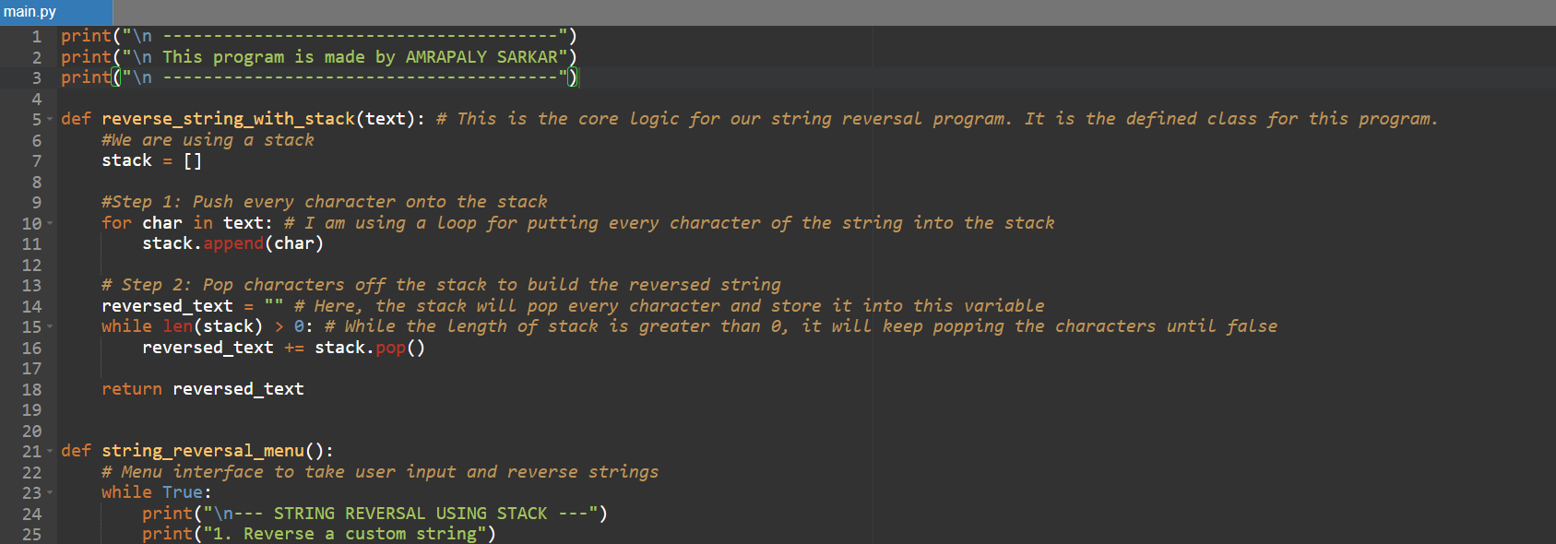
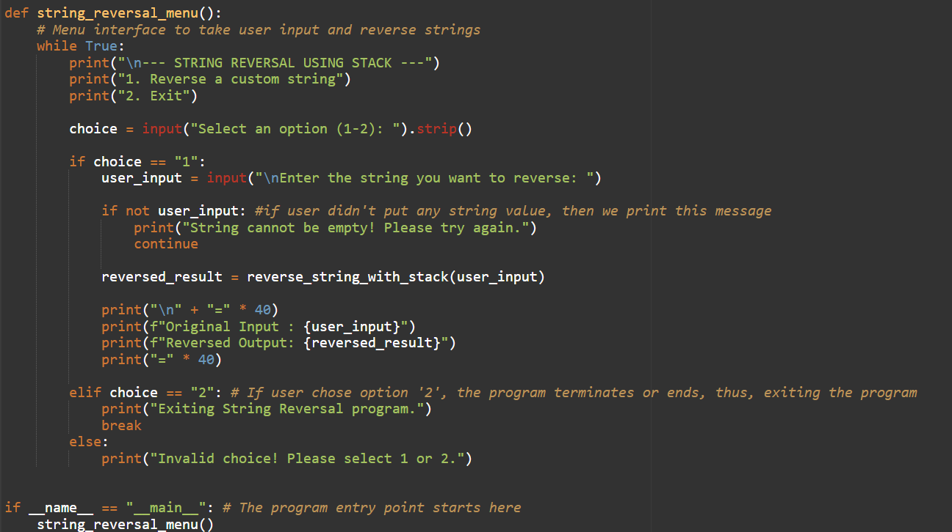
Now, let us see what happens when the user inputs a string into this program:
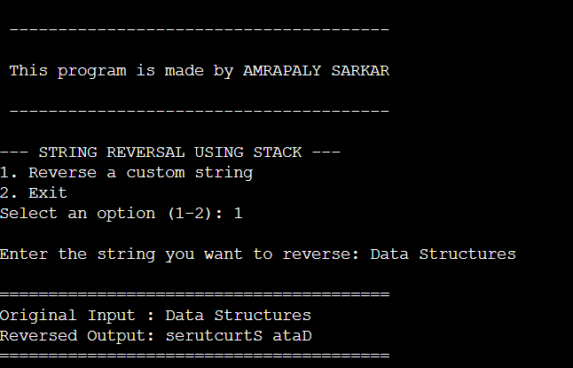
We inputted the string “Data Structures”, which got reversed into the string that is shown in the above picture.
Thus, this is how a stack is used to reverse any string.

Let us now move on to the next one:
- Parenthesis Matching

This program shows how you can ensure that any equation with multiple parenthesis in it has both the opening and closing parenthesis (or brackets).
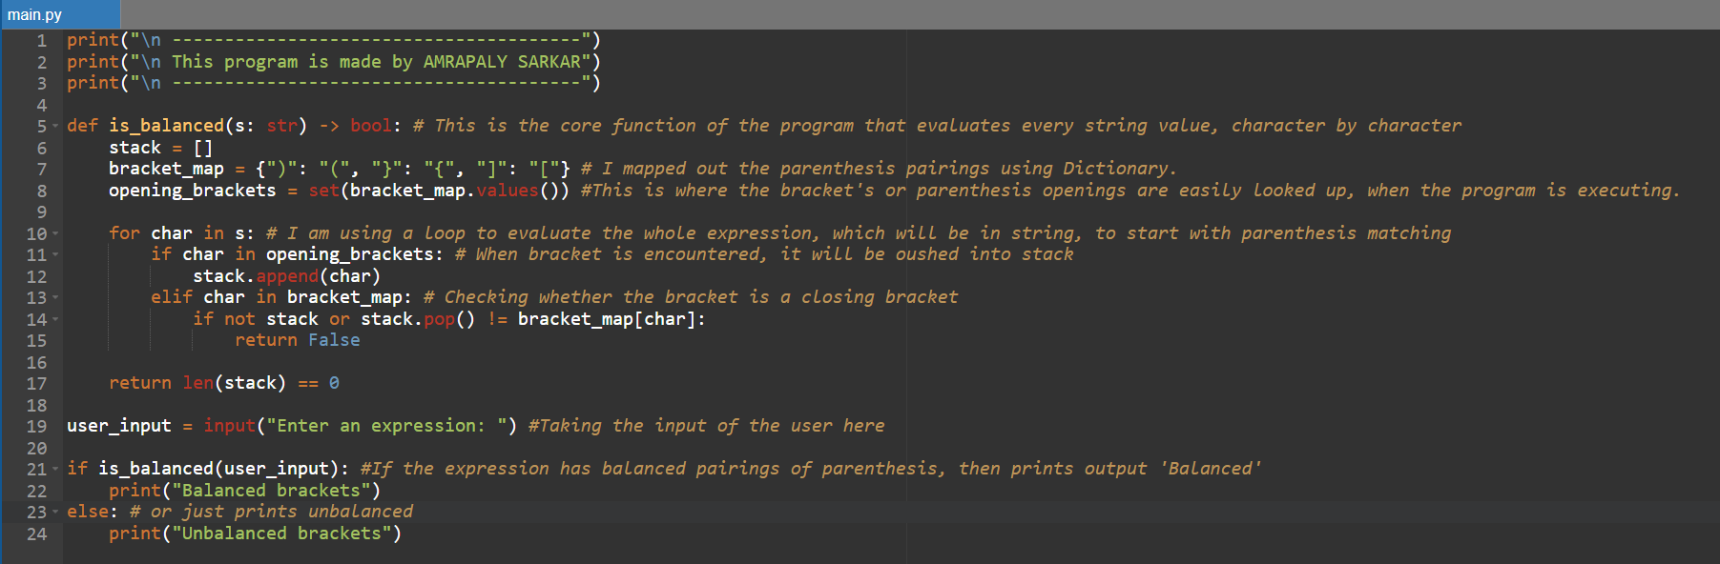
Now, let’s see how this program works.
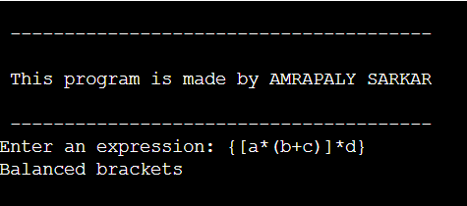
We inputted the expression, ‘{[a*(b+c)]*d}’, then checked if it has matching parenthesis, as in, has both the closing and opening brackets. It has all the matching brackets, thus, it is Balanced.
Now, let us see when it is the other way around.
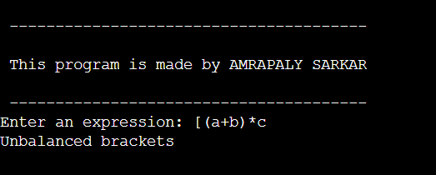
We took ‘[(a+b)*c’, as the expression. We checked and got unbalanced, which is correct, as it does not contain the closing square bracket.

Thus, these were some applications and operations performed using a stack data structure.

Q.7. Write a program in Python to perform the following:
- General Queue Operations
- Insertion
- Deletion
- Circular Queue Operations
- Insertion
- Deletion

Queues is a Linear Data Structure that uses the FIFO(First In, First Out) principle.
There two main types of queues that we are focusing on here:
- Linear Queue
- Circular Queue
Here is the code for the program: (Next Page)
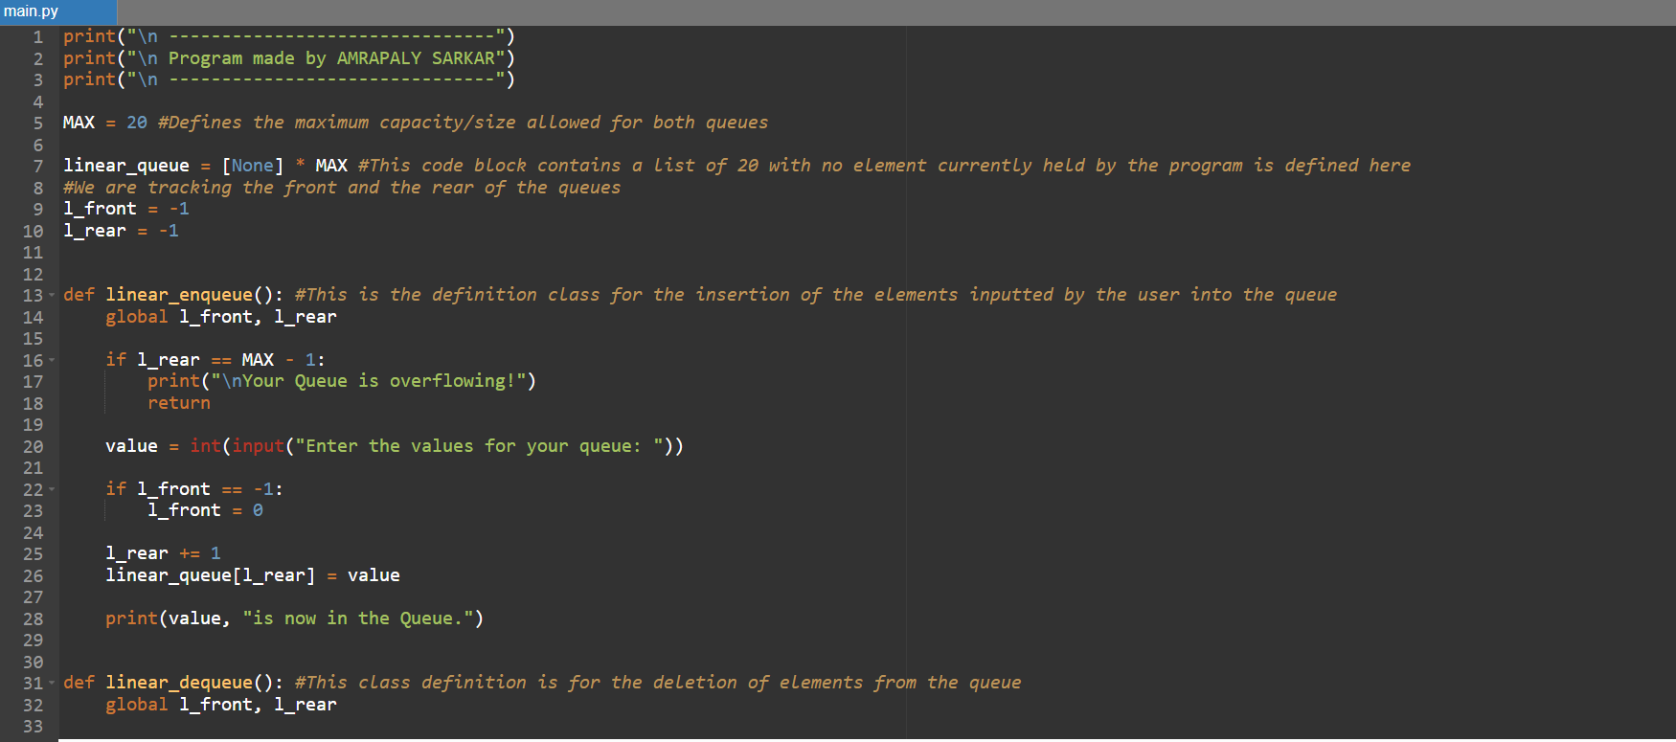
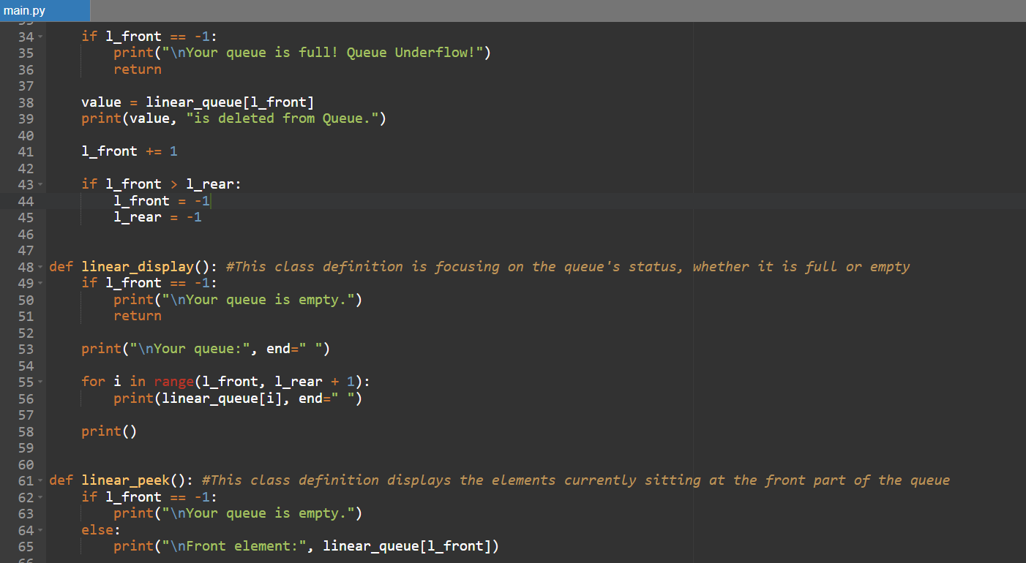
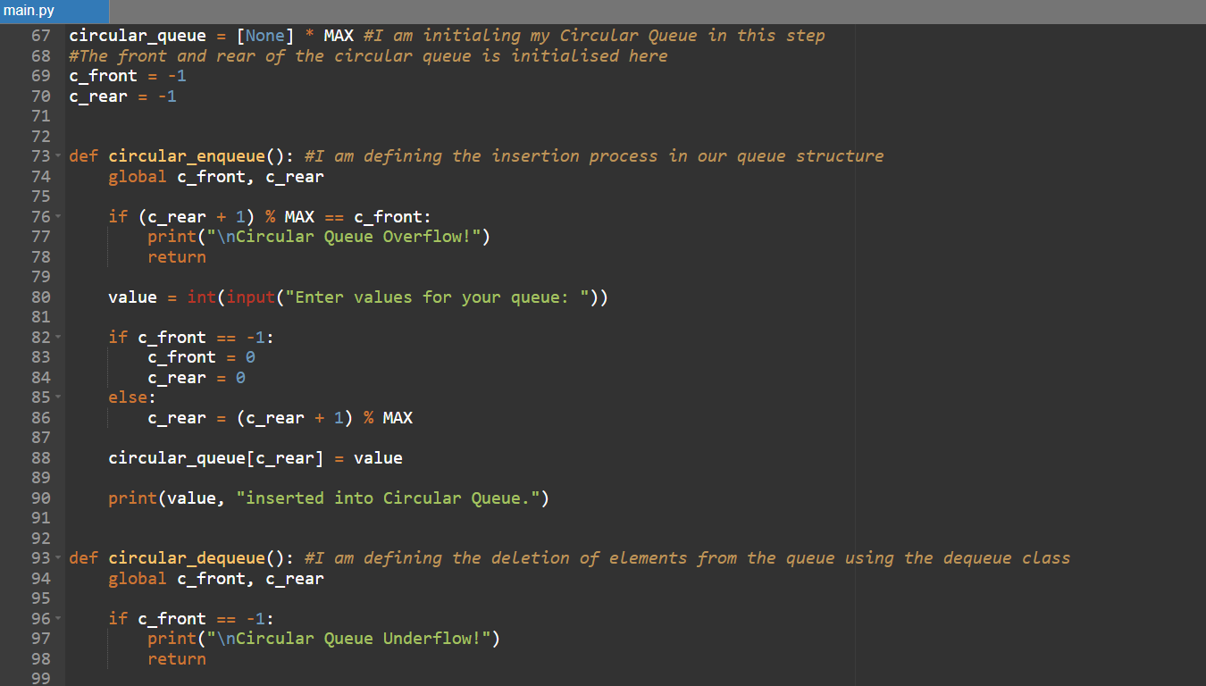
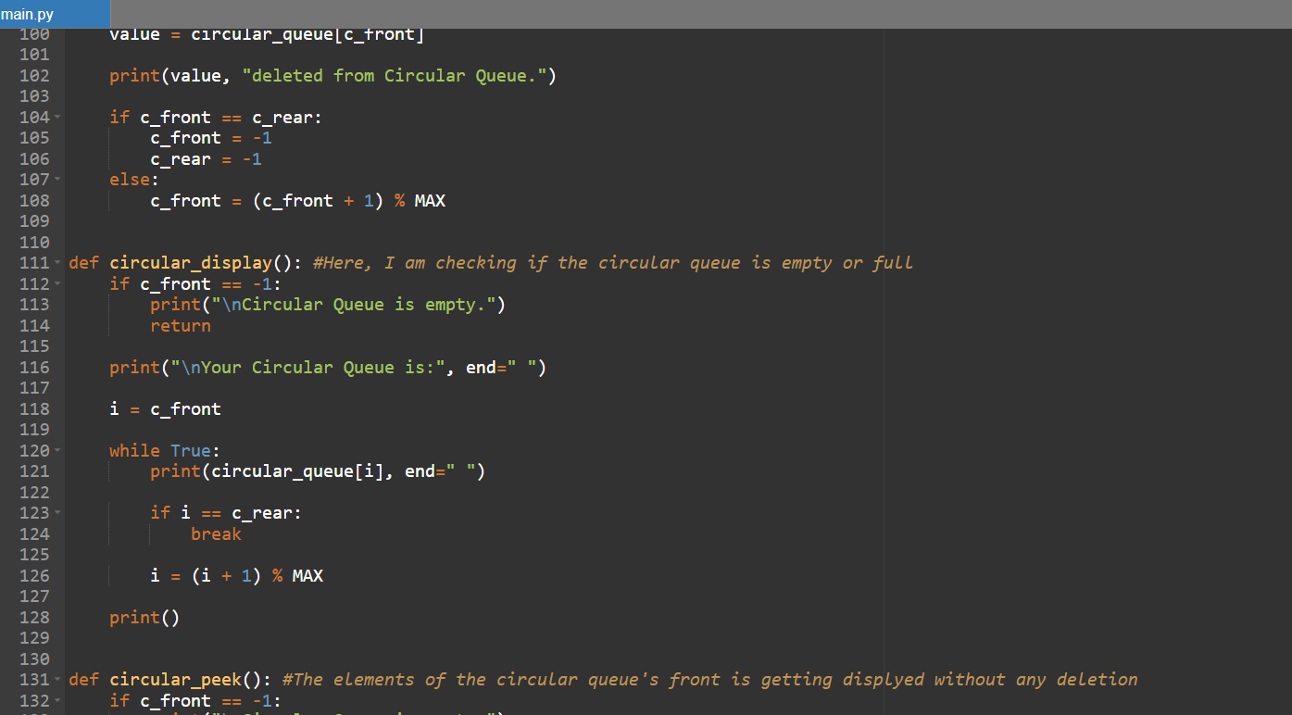
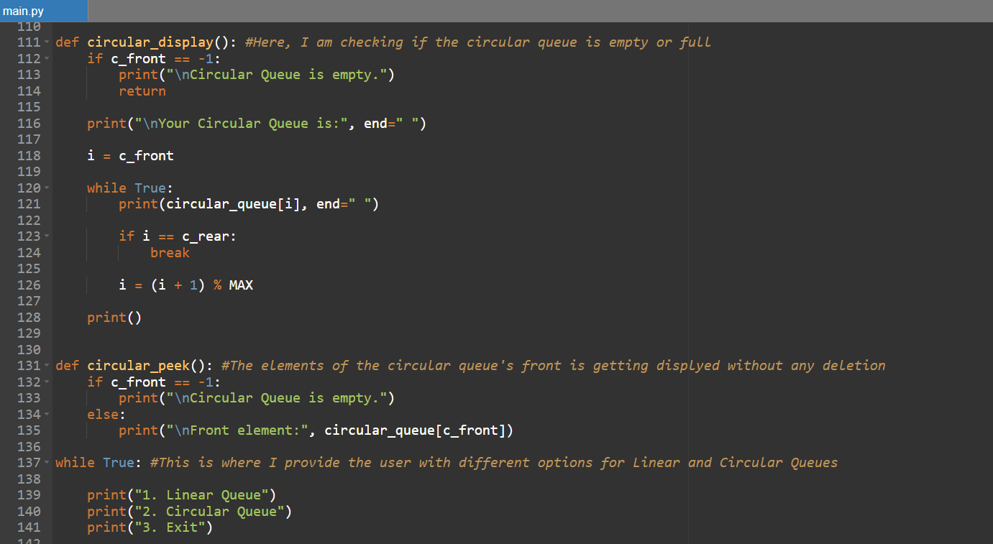
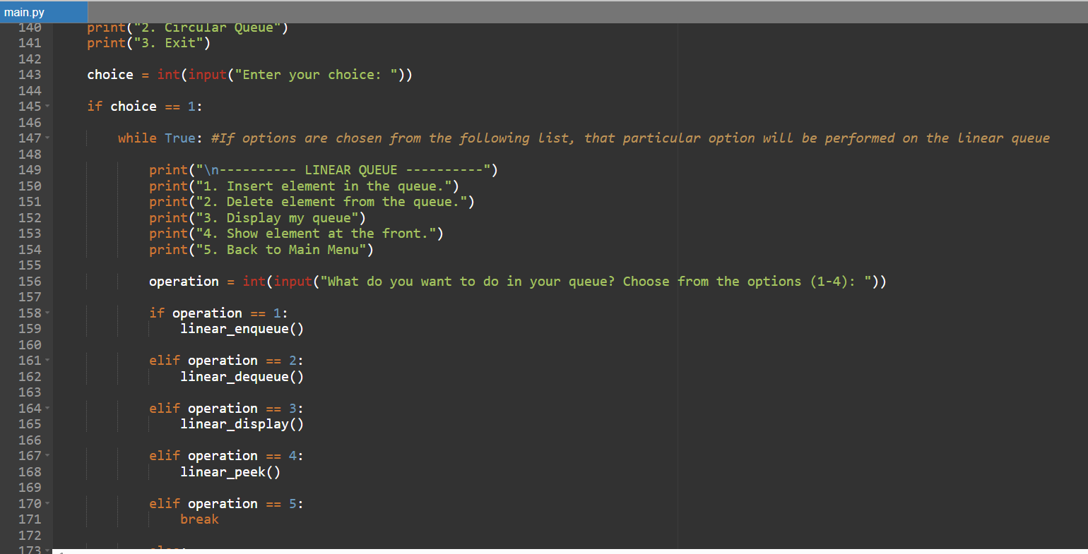
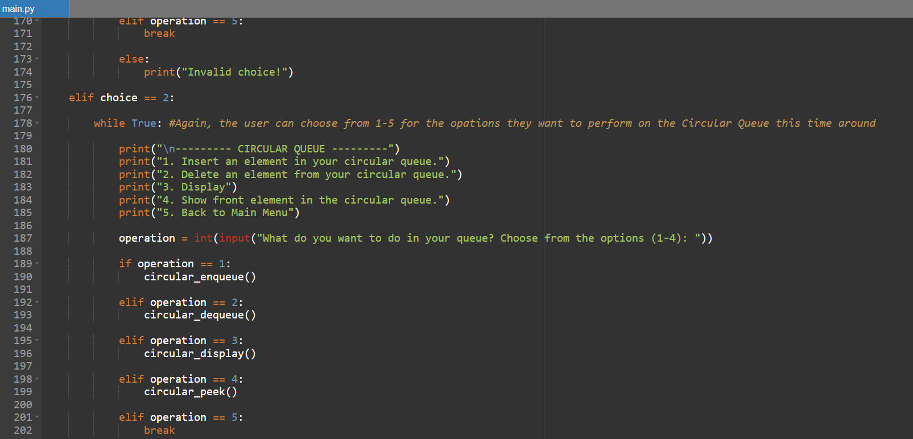
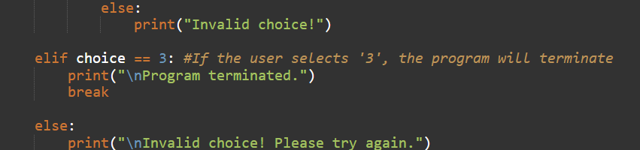
The outputs for this program are:
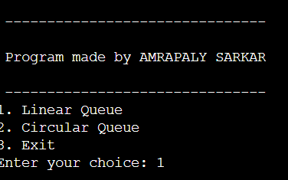
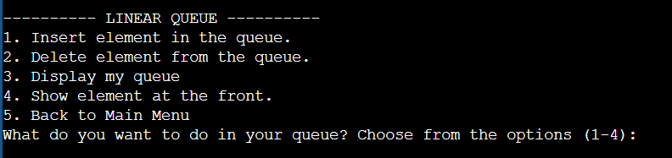
We are choosing to insert the element in our linear queue:
The queue has the space to store upto 20 data elements.
When we perform deletion:
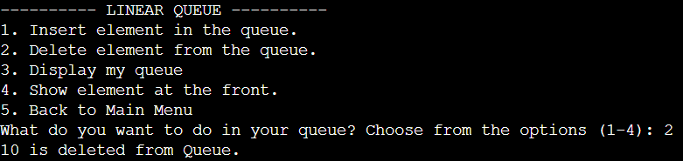
The first element in the queue, i.e., 10, gets deleted from the linear queue from the front of the queue. This follows the principle of FIFO.
Now for Circular Queues:
Insertion:
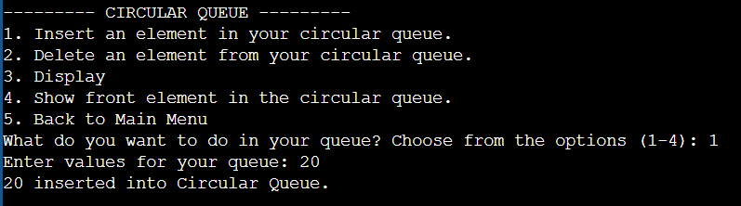
20 is now in the circular queue. Let’s add some more:
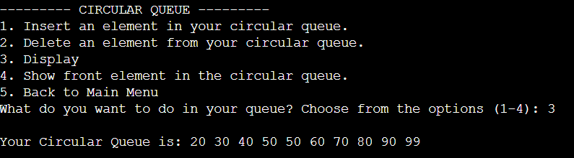
Our circular queue will look something like this.
The best thing about this is, when the queue is completely full, and we delete some of the elements to accommodate the space for new insertions, they directly inserted into those empty spaces in the queue after deletion!
This saves us from a wastage in space when you want to insert a data element, but it doesn’t get inserted, because it seems ‘full’, even when there are empty spaces in the front.
It gets rid of the wastage of space problem, that we would encounter in a Linear Data Structure.

Q.8. Write a program to perform the Infix to Postfix conversion using Python.

The Infix Expression is the standard way of how people write an expression.
For example: (A*(B+C)) or (A + B)
Now, Postfix Expression is the way of writing an expression, where the operators are written after the operands.
For example: (AB+) is the same as (A +B).
The main difference between the Infix Expression and the Postfix Expression is where the operator is placed in the expression. If the operators are in between operands, then it is an Infix, while when the operators are placed after the operands, then it is a Postfix.

Here is a Python program for the Infix Postfix Expression conversion:
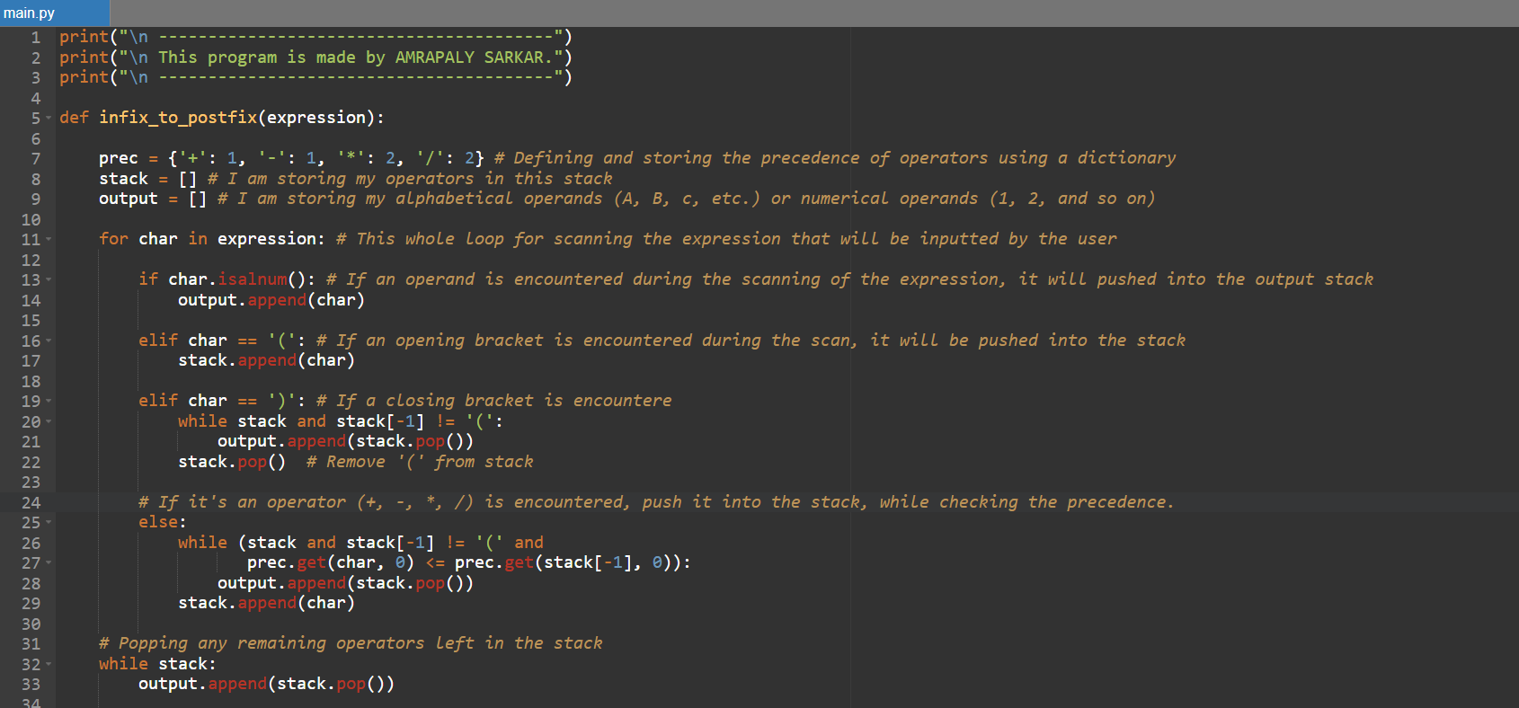
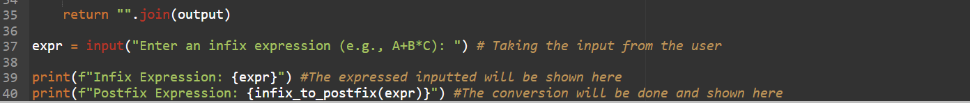
Let us see how it works:
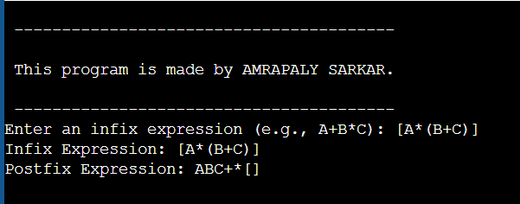
You can clearly see the difference and the conversion. The Operands (A, B, C) were pushed into the Output, while the brackets [], () and Operators ( *, +) were pushed into the Stack, when ever they were encountered in the iteration or scanning.

Here is another way of how Infix Postfix works in Python:
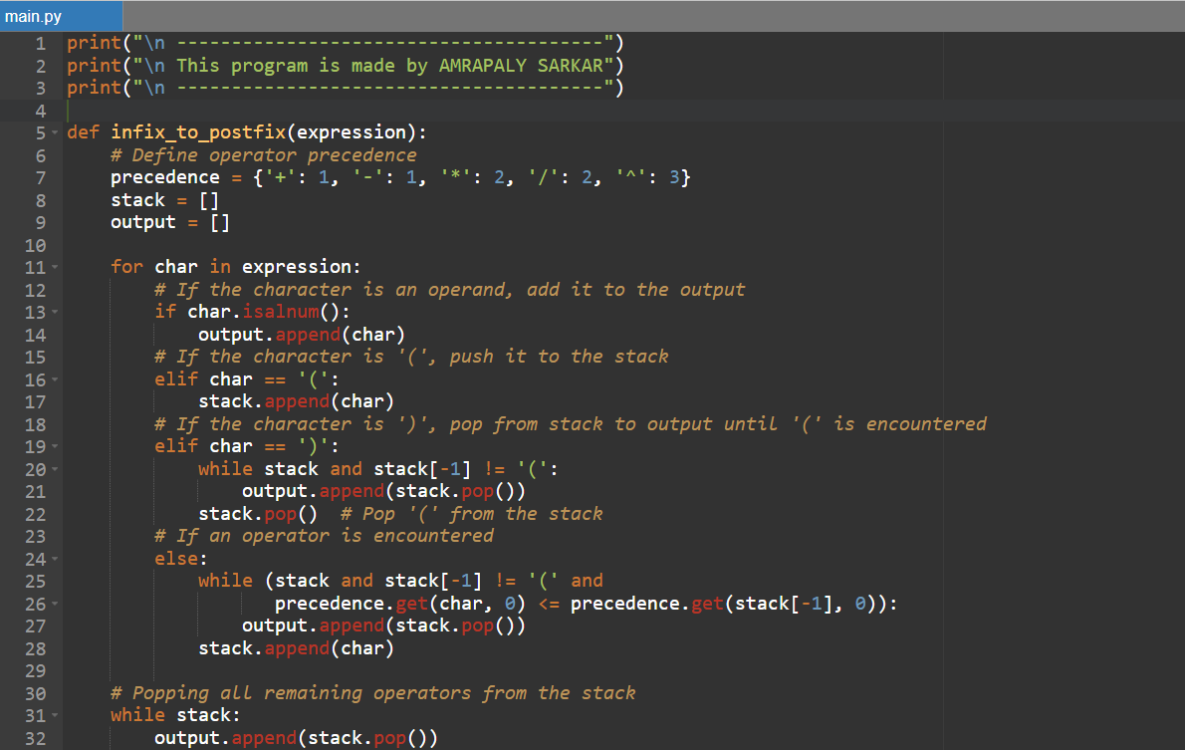
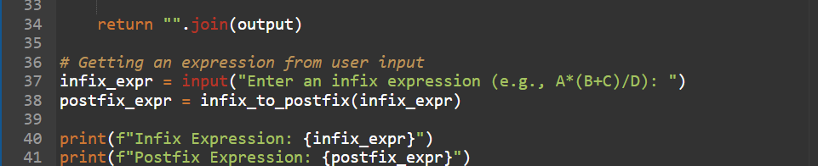
Let us see how this one works:
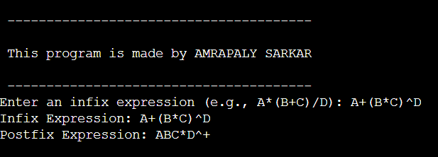

Thus, this is how an expression is converted from Infix to Postfix using Python.

Q.9. Write a program in Python to perform Quick Sort.

Quick Sort is a sorting algorithm that follows the Divide and Conquer concept. Which means that, to sort elements, the set of elements are divided into smaller parts to sort them, then put them all back together into a sorted order.

The program for Quick Sort in Python is as follows:
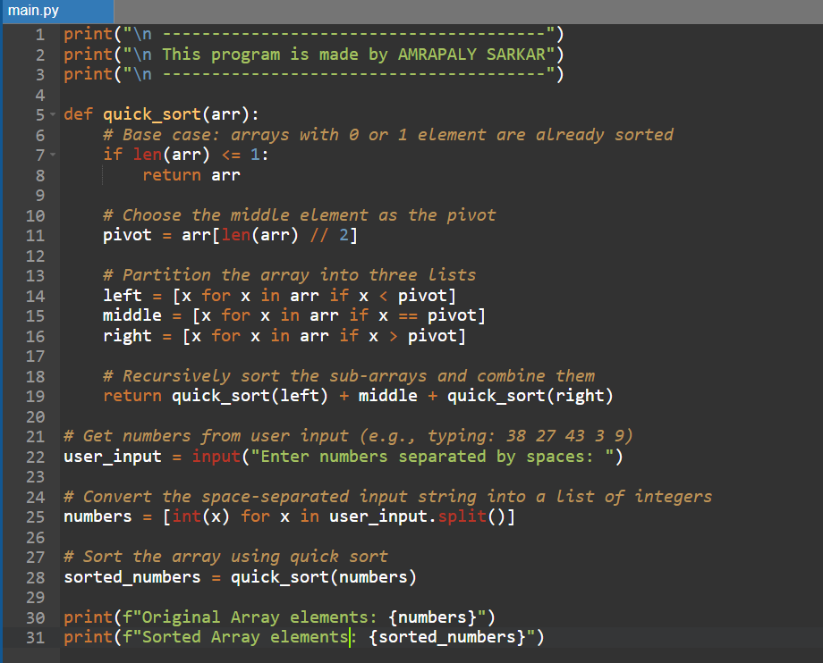
Let’s see how this works:
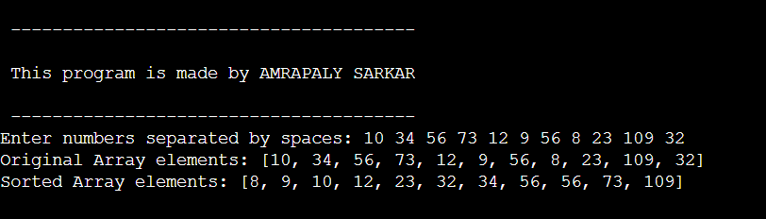
See how the elements are sorted? This is done by Divide and Conquer principle used by Quick Sort. This is a quick and simple way for sorting a group of elements.

Another output:
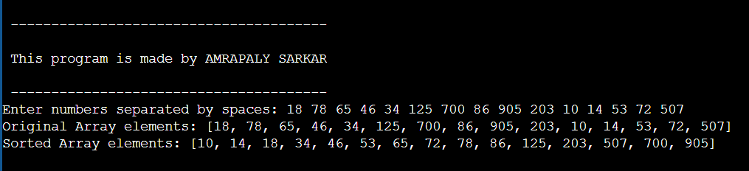

Thus, this is how Quick Sort works in Python.

